OpenRouter: Concepts, Integration, and Becoming a Provider

Core Concepts and Integration

What Is OpenRouter

AI model vendors use different standards. They require unique authentication schemes, distinct request formats, and separate billing accounts. Integrating with five providers requires maintaining five separate systems.

OpenRouter solves this issue by unifying these connections. You integrate your system once. This single setup gives you access to hundreds of models across 60+ providers through one API key and an OpenAI-compatible endpoint.

OpenRouter does not train or host frontier models itself. Instead, it acts as an abstraction and marketplace layer in front of other providers. It converts incoming requests into a single consistent format. It selects the best provider to handle each request. It automatically switches to a backup if a provider degrades. Finally, it consolidates all payments into one bill, regardless of how many providers you use.

Key Concepts

A few key terms define OpenRouter's architecture:

- Models — These use an author/slug ID (e.g., anthropic/claude-sonnet-4). Multiple providers can host the same model. Each provider serves as an "endpoint," and OpenRouter directs traffic between them.
- Providers — These are the organizations running the actual inference. They include cloud AI labs, GPU hosting companies, or private enterprise deployments. When multiple providers serve the same model, they compete on price, speed, and reliability.
- Routing and fallback — OpenRouter automatically balances traffic by price across providers for a given model. It redirects traffic automatically if a provider fails or slows down. Teams can override these rules by locking specific provider order or disabling fallbacks.
- Credits and pricing — Usage deducts money from a prepaid USD balance. Charges follow each provider's declared rates (per token, per image, or per second) plus OpenRouter's platform fee.
- Rate limits and capacity — Providers set their own traffic limits. OpenRouter enforces these limits and redirects traffic away from overloaded or failing providers.
- BYOK (Bring Your Own Key) — Teams can use their existing direct contracts or discounts with providers like Anthropic, OpenAI, Azure, Bedrock, or Vertex. They simply add their API credentials to OpenRouter. Usage then bills directly to the team's provider account, with OpenRouter adding only a small platform fee.

Component Architecture
The diagram below shows how a request moves from a client application through OpenRouter's system to a provider endpoint. It also illustrates where private models sit relative to public models.

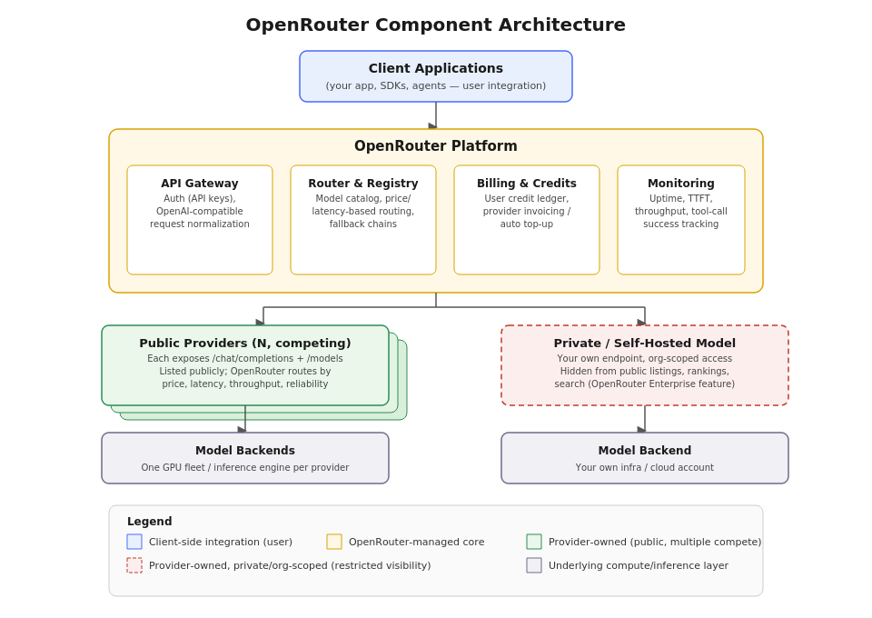

Integrating as a User (Consumer)

Integrating as a consumer requires only three simple steps:

- Obtain an API key from the OpenRouter dashboard.
- Configure your OpenAI-compatible SDK to use OpenRouter's base URL (https://openrouter.ai/api/v1), or make direct HTTP requests:
Bash
curl https://openrouter.ai/api/v1/chat/completions \
-H "Authorization: Bearer $OPENROUTER_API_KEY" \
-H "Content-Type: application/json" \
-d '{
"model": "anthropic/claude-sonnet-4",
"messages": [{"role": "user", "content": "Hello"}]
}'

- Select models using their ID (author/slug). You can optionally set custom routing rules, such as restricting providers, setting data-residency policies, or customizing fallback order. You can also track your spending against your credit balance.
OpenRouter matches the OpenAI Chat Completions API design closely. Because of this, existing OpenAI code usually only needs a new base URL and API key to work.

Adding Your Own Privately Hosted Model

You can consume models from OpenRouter's catalog, but you can also host your own. Teams can register custom models—such as a fine-tuned model or a private open-weight deployment—and route requests through the same OpenRouter API. OpenRouter calls this feature Private Models.

Private models differ from standard listings in several ways:

- Access is strictly restricted. Only approved users and organizations can call the private model. It will not appear in public model lists, search results, rankings, or benchmarks.
- The API remains identical. Approved users call private models using the standard chat-completions endpoint and request format. The private model ID works like any other model ID and can be added to custom fallback chains and routing rules.
- The endpoint must support the OpenAI API format or a close variant that OpenRouter can easily adapt.
- Access requires an Enterprise plan. Teams request setup through an account representative or enterprise signup form. They must supply details about the model, hosting setup, API format, and access rules.
Private models bridge user integration and provider hosting. A private model uses the same infrastructure as a public provider, but without public marketplace features like public listings, open routing, and visible pricing.

Integrating as a Provider

Becoming a public provider requires more setup than consuming models or hosting a private model. Public providers run production inference infrastructure that handles arbitrary user traffic at scale. They must also maintain published pricing and clear uptime guarantees. Below section covers these details.

RackAI with OpenRouter

There are 2 possible areas of integration with OpenRouter.

- Become a registered provider for users to consume inference endpoints hosted by Rackspace – This definitely needs more work on our side to meet what is expected of a provider. Details are captured in the next section.
- RackAI users can add their private model endpoints in OpenRouter as a “Private Model” - RackAI already enables this with models deployed through it. With API key support coming as part of the Identity and Access Control work stream, users should be able to achieve this easily. Probably needs some good documentation or pointers on how to do this in the UI.

Becoming a Registered Provider

Becoming a provider requires setting up infrastructure and APIs that meet OpenRouter's requirements for routing, billing, and monitoring. These requirements span three main areas: infrastructure, API design, and product features.

P0 classification is a must have to be part of the OpenRouter ecosystem. P1 classification helps us do well in the OpenRouter marketplace but doesn’t block us from entering the marketplace.

Infra-Layer Requirements
Requirement | Priority | RackAI notes
Provide production-ready capacity that supports your stated traffic limits, including extra room for sudden traffic bursts. OpenRouter assigns traffic based on your reported capacity and real-time performance. | P0 | RackAI needs to support inferencing as a service. Today inferencing is achieved by users deploying a model of their choice, there is no inference as a service option.
Implement autoscaling and load shedding. If your servers overload, return early 429 error codes instead of holding requests in queues. Long queues increase reported latency and reduce your routing priority. | P1 | RackAI doesn’t necessarily return 429 today when requests take long to be serviced
Support native token streaming. Emit tokens as your system generates them. Do not buffer output into a single response block. OpenRouter measures performance using end-to-end generation speed. | P0 | Unsure about the current RackAI behavior and need to confirm this.
Offer multi-region or defined-region hosting if your target customers require geographic routing or data-residency guarantees. Declare datacenter locations for each model to support location-based routing. | P1 | RackAI doesn’t have multi region support today.
Set up automated billing. OpenRouter requires a method to pay you automatically via automatic account top-ups or monthly invoices. | P0 | RackAI doesn’t have any billing mechanism. While metering is being planned, there is no payment system integration on the current roadmap

API-Layer Requirements
Requirement | Priority | RackAI notes
Provide an OpenAI-compatible /chat/completions endpoint. The endpoint must support streaming and non-streaming modes and return token usage data for both. | P0 | RackAI supports OpenAI compatible chat completions endpoint today.  Token usage data is something in the works. Need to confirm how it works with openrouter
Provide a /models endpoint that lists your full catalog using OpenRouter's typed schema. Include pricing, context window length, maximum output tokens, supported parameters, capacity limits, and datacenter locations. Every input and output type (text, image, audio, video, files, embeddings) must define its own pricing and capacity | P0 | RackAI doesn’t provide such an endpoint today.
Return accurate error codes. Authentication errors, payment failures, missing models, and internal server errors degrade your uptime rank. Client errors (malformed input) and rate limits do not lower your uptime score. Correct error codes protect your overall priority. | P0 | RackAI does return expected error codes. 429 returns may need to be added in (called out in above section)
Send keep-alive signals during long requests (e.g., reasoning models). This prevents OpenRouter from timing out and switching to a backup provider | P1 | RackAI doesn’t do this today. This may be an OpenRouter specific integration.
Support reliable tool calling. OpenRouter prioritizes providers with high success rates for function and tool calls. Providers with low success rates receive lower priority. | P1 | This is mostly model specific. If RackAI supports running models which have good tool calling support, this item would be satisfied.

Feature-Layer Requirements
Requirement | Priority | RackAI notes
Declare model capabilities. Provide a machine-readable document listing supported features for each model. Include context size, supported modalities, streaming support, structured outputs, tool calling, reasoning tokens, and custom provider parameters. | P0 | This needs to be published.
Define clear unit pricing. Set your own per-unit rate in USD. OpenRouter does not negotiate rates. It adds a platform fee to your base price and factors cost into routing decisions. | P0 | This needs to be figured out and integrated into the billing system.
State compliance and data policies clearly. Declare zero-data-retention options, HIPAA compliance, and other certifications per model. This helps users review security requirements easily. | P1 | This needs to be published.
Use self-service lifecycle controls. Control model availability directly through schema settings without contacting OpenRouter support. You can stage models privately, pause endpoints, offer free access, or apply user discounts. | P1 | These controls or proces need to be defined within Rackspace.
Monitor performance metrics. Access a dashboard containing real-time performance data. Review speed, tool-call success rates, and benchmark rankings so you can fix issues before losing traffic. | P1 | This is currently being built as part of our CSP layer. Need to confirm it meets what we need to effectively monitor deployments exposed to OpenRouter.

Onboarding Path (Summary)

- Apply and pass the technical review. OpenRouter verifies your API design, /models schema, billing connection, and privacy policy.
- Complete test onboarding. OpenRouter sends test traffic to evaluate latency, throughput, and error response handling before sending live users.
- Go live. Your models enter the active routing pool. Your traffic grows as your endpoint shows competitive pricing, low latency, high throughput, and strong reliability.
- Maintain performance. OpenRouter constantly tracks system uptime, speed, and tool-calling success. If uptime drops below reliability standards, your routing priority decreases. If uptime drops below 80%, your endpoint becomes a last-resort fallback until stability recovers.

